Assignment Week 4 – Entrepreneurship
- First give a short introduction to your business plan scored higher in the last class activity.
- Read about the Barringer / Ireland Business Model in the book and online.
- Carefully write about the 12 categories listed in tables on the following pages.
- Below colorful table is just a sample for your knowledge.
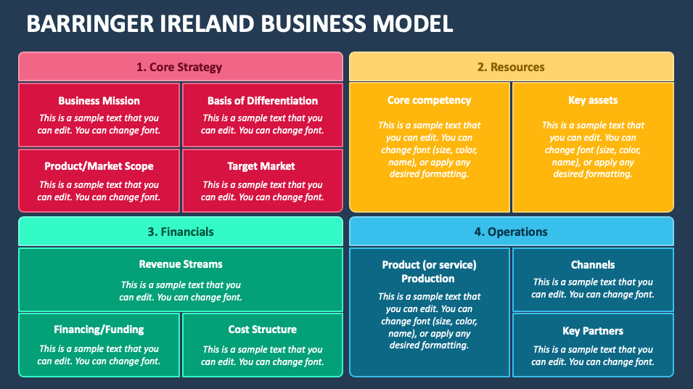

- Core Strategy
Business Mission | Basis of Differentiation
Target Market | Product Market / Scope

- Resources
Core Competency | Key Assets

- Financials
Revenue Streams

Financing / Funding | Cost Structure

- Operations
Product / Service Production | Channels
 | Key Partners

